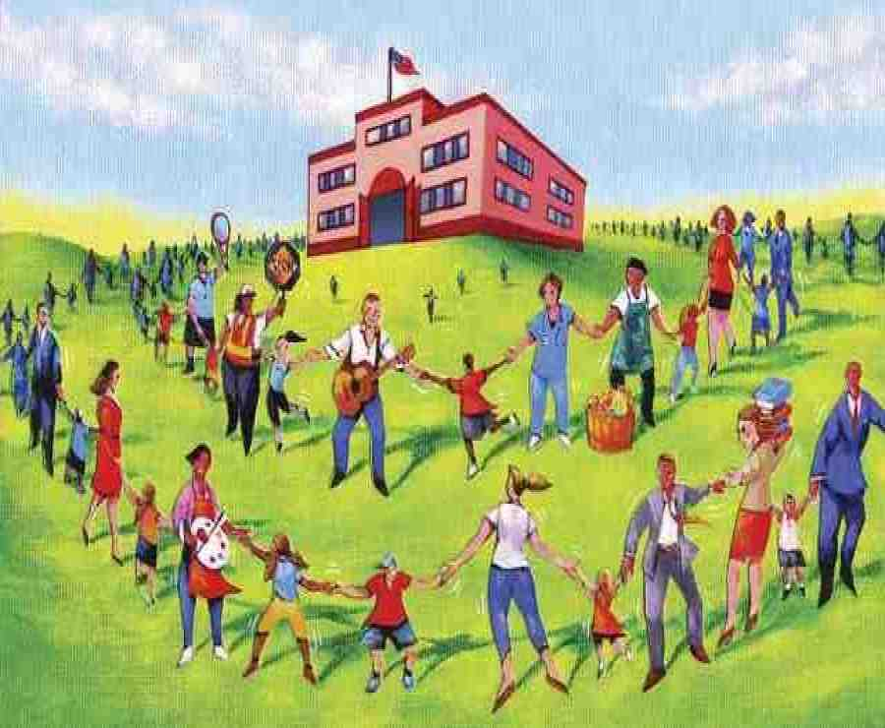

[This Photo](https://bloom-at.blogspot.com/2016/06/2016-medley-17.html) by Unknown Author is licensed under [CC BY-SA-NC](https://creativecommons.org/licenses/by-nc-sa/3.0/)